CENWP-OP-B
09 July 2003
MEMORANDUM FOR THE RECORD

SUBJECT: Steelhead dead at Bonneville’s Adult Fish Facility (AFF).

- Project biologists received a phone call from Tanna Clark, with ODFW on 09 July notifying them of a clipped steelhead mort.
- The fish had come down the north flume with bleeding gills. It expired shortly after reaching the anesthetic tank.
- That is the only fish that has been seen injured in the AFF as of late. The north flume recently had the wedge wire replace so it is believe the fish was injured before entering the flume.
- The fish was released down the glory hole.
- Photos are attached.

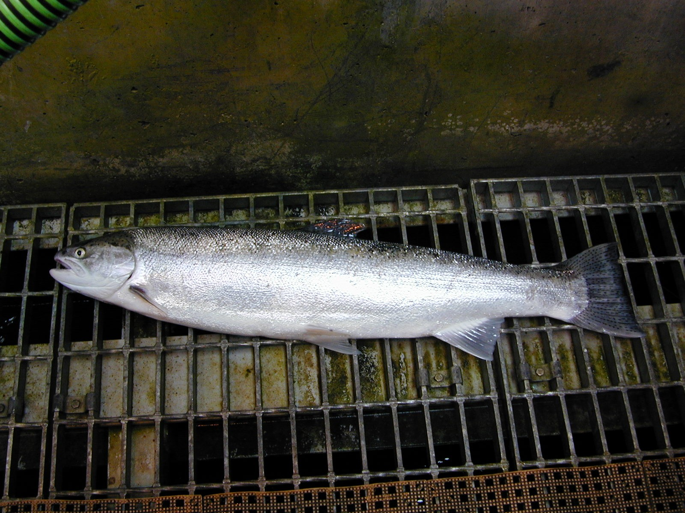
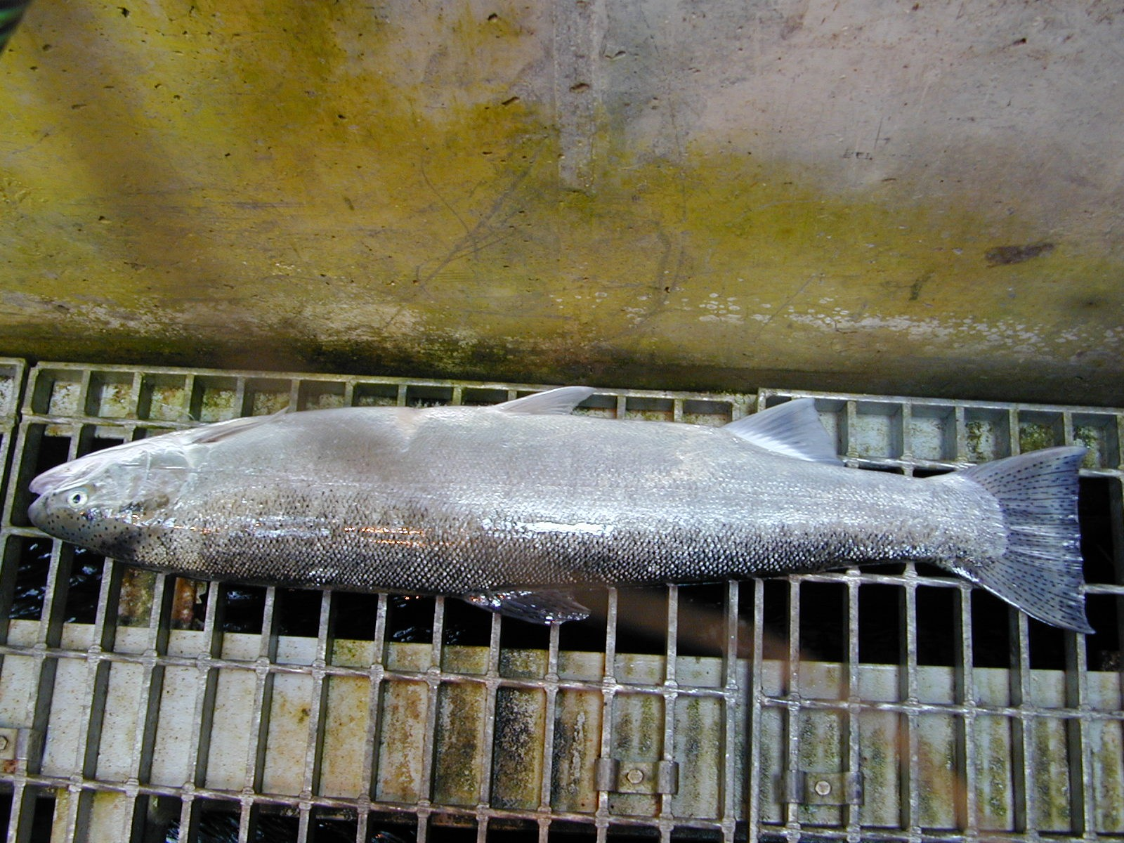

Tammy Mackey
Bonneville Fisheries Biologist

